

**IPF Coach Licence Level II**

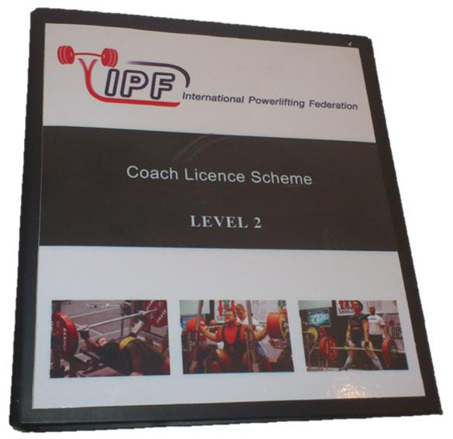

**Course Manuel**

**OBJECTIVES**

The IPF is designed to train and educate coaches from around the World. The programme attempts to promote and develop excellence in coaching. The Course provides coaches with a systematic way to improve their knowledge and skills in the theoretical, technical and practical aspects of Powerlifting coaching.

**ORGANISATION STRUCTURE**

The IPF will organise two coach licence scheme, level II and Level I - Level II must be taken before Level I, They are intensive, concentrated, and intermediate level courses. The courses will be organised April and September each year depending on demand. See the attached application form for the course. The duration of the course will be 3 days.

**GENERAL SUBJECTS**

The curriculum of the theoretical part (general subjects) deals with the art and science of coaching powerlifting, the content of the theory courses cover the Broader education of the programme and includes the following subjects: training theory, sport psychology, exercise and conditioning, coach in action, strength training and injuries, women and sport, youth and sport, disability and sport, technical rules, Anti-Doping education, sport management, sport and nutrition and other related subjects.

**SPECIALISATION**

The Sport Specialisation component has two parts: technical and practical. The technical part provides sport-specific information, which includes classroom instruction, sport-specific presentation, participatory activity and formal evaluation. The content includes coaching information pertaining to Powerlifting. These courses apply coaching principles. Skills, training methods, strategy and tactics, detection and correction of errors as well as psychological preparation are among the topics covered. The practical component involves actual coaching experience, practical lessons. The practical part of the programme involves applying theoretical and

Technical knowledge to actual coaching situations, coaches coaching will be evaluated by on-the-scene observation. The practical and technical parts will also contain home assignments.

**EXAMINATIONS**

The exams will consist of written and practical. Examinations in the sport of Powerlifting consist of sports theory and sports practice. The examination is taken before an IPF International coach. Participants who completed the course with a final Examination and pass will receive an IPF Coach Diploma.

**PRECONDITIONS FOR APPLICATION**

* - Recommendation from your National Powerlifting Federation
* General knowledge of the English language if not you must bring a translator
* Information regarding the condition of your health
* Copy of valid passport

**COURSE FEE**

750 EURO per person

**THE COURSE FEE WILL INCLUDE THE FOLLOWING:**

* Course Manuel
* Instruction
* Examinations
* Accommodation include breakfast, lunch and evening meals
* Transportation to and from the airport
* The use of all facilities of the LMC (sport centre
* All participants of the course will receive a IPF official course T/Shirt
* Successful participants will receive IPF Diploma

**Contact Details**

Ralph Farquharson

Calle Galena 5, Casa 44

Villapiedra

Orihuela Costa

03189

Alicante

Spin

Tel: +34 966 733367

Mobile: +34 650041559

E-Mail: [ralph@europowerlifting.org](mailto:ralph@europowerlifting.org)

[**www.powerlifting.sport**](http://www.powerlifting.sport)